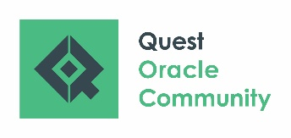 | Record of Participation  PeopleSoft RECONNECT Dive Deep  October 4 – 7, 2021

ATTENTION REGISTRANT: A Record of Participation form is a document on which you may record the specific details of your participations in order to receive NASBA CPEs. Final determination of the acceptance of a program is up to the individual licensing authority.

Please email this completed form to education@questoraclecommunity.org to receive your certificate.

# | Date | Session ID | Title of Session | Presenter’s Name | Hours  Attended
1.
2.
3.
4.
5.
6.
7.
8.
9.
10.
11.
12.
13.
14.
15.
 |  |  |  | Total Hours:
Registrant Name:
Registration Email:
Company:

