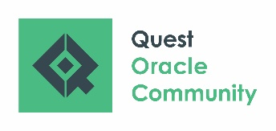 | Record of Participation  RECONNECT Envision  April 26 – 29, 2021

ATTENTION REGISTRANT: A Record of Participation form is a document on which you may record the specific details of your participations in order to receive NASBA CPEs. Final determination of the acceptance of a program is up to the individual licensing authority.

Please email this completed form to education@questoraclecommunity.org to receive your certificate.

# | Date | Session ID | Title of Session | Presenter’s Name | Hours Attended
1
2
3
4
5
6
7
8
9
10
11
12
13
14
15
Total Hours:

Registrant Name:
Registration Email:
Company:

